/*

* Justin Mendes

* November 22, 2016/Edited January 15, 2017

* Unit 4 Activity 1 Program/Question 1

* This program will ask the user to input a phrase and it will show them the number of vowels their phrase contains, it will also restart based on the user input at the end.

*/

**import** java.io.BufferedReader;

**import** java.io.IOException;

**import** java.io.InputStreamReader;

**public** **class** CountVowels

{

**public** **static** **void** main(String[] args) **throws** IOException

{

//Starts the first loop (without it, will not run)

**int** restart = 1;

**while** (restart == 1)

{

//Variable Declarations and Initializations

String phrase;

**int** vowelCount = 0;

**char** vowel[] = **{**‘a’, ‘e’, ‘i’, ‘o’, ‘u’};

BufferedReader input = **new** BufferedReader(**new** InputStreamReader (System.***in***));

System.***out***.println("Count Vowels\n===========");

System.***out***.println("Type a sentence and this program will tell you\nhow many vowels there are (excluding 'y'):\n");

phrase = input.readLine().toLowerCase();

**for** (**int** i = 0; i != phrase.length(); i++)

{

**for** (**int** eachVowel = 0; eachVowel < 5; eachVowel++)

{

**if**(vowel[eachVowel] == phrase.charAt(i))

{

vowelCount += 1;

}//end if

}//end loop

}//end loop

System.***out***.println("There are " + vowelCount + " vowel(s) in the phrase you've entered.\n");

System.***out***.println("Press 1 to try a new phrase or press any other number to exit.");

restart = Integer.*parseInt*(input.readLine());

}//end while

}//end main

}//end class

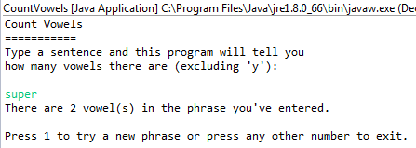

/*

* Justin Mendes

* November 23, 2016

* Unit 4 Activity 1 Program/Question 2

* This program will have the user enter a word. Using the letters of the word, it will form the shape of a rectangle. (moving the letters to the left one position each time)

*/

**import** java.io.BufferedReader;

**import** java.io.IOException;

**import** java.io.InputStreamReader;

**public** **class** WordRectangle

{

**public** **static** **void** main(String[] args) **throws** IOException

{

//Variable Declaration and Initializations

**int** restart = 1;

**while**(restart == 1)

{

String firstPart, secondPart, word;

BufferedReader input = **new** BufferedReader(**new** InputStreamReader (System.***in***));

System.***out***.println("Welcome to Word Rectangle!\n==============================");

System.***out***.println("Enter a word, and this program will make a word rectangle with it.");

word = input.readLine();

System.***out***.println("Here is the " + word.toUpperCase() + " rectangle:");

**for** (**int** i = 0; i != word.length(); i++)

{

firstPart = word.substring(i);

secondPart = word.substring(0, i);

System.***out***.println(firstPart.toUpperCase() + secondPart.toUpperCase());

}//end loop

System.***out***.println("Press 1 to try another word. Press anything else to exit.");

restart = Integer.*parseInt*(input.readLine());

}//end loop

}//end main

}//end class

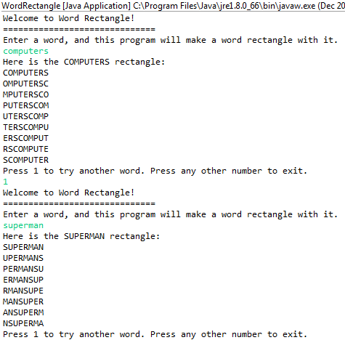

/*

* Justin Mendes

* November 23, 2016

* Unit 4 Activity 1 Program/Question 3

* This program will have the user enter a compass direction and then give directions based on the input.

*/

**import** java.io.BufferedReader;

**import** java.io.IOException;

**import** java.io.InputStreamReader;

**public** **class** Compass

{

**public** **static** **void** main(String[] args) **throws** IOException

{

//Variable Declarations and Initializations

**int** restart = 1;

**while** (restart == 1)

{

String direction;

BufferedReader input = **new** BufferedReader(**new** InputStreamReader (System.***in***));

System.***out***.println("Compass Directions\n==============");

System.***out***.println("Input a compass direction (E.g. N08E):");

direction = input.readLine().toUpperCase();

**switch** (direction.charAt(0))

{

**case** 'N': System.***out***.print("Start facing North. ");

**break**;

**case** 'S': System.***out***.print("Start facing South. ");

**break**;

}//end switch

System.***out***.print("Turn " + direction.substring(1 , 3) + " degrees towards ");

**switch** (direction.charAt(3))

{

**case** 'E': System.***out***.println("East.");

**break**;

**case** 'W': System.***out***.println("West.");

**break**;

}//end switch

System.***out***.println("Press 1 to try again.");

restart = Integer.*parseInt*(input.readLine());

}//end loop

}//end main

}//end class

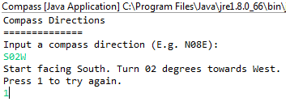

/*

* Justin Mendes

* November 24, 2016/Edited January 15, 2017(did not use StringBuilder)

* Unit 4 Activity 1 Program/Question 4

* This program will print the user's inputted word backward and declare if the word is a palindrome (spelt the same backwards as forward)

*/

**import** javax.swing.JOptionPane;

**import** java.io.BufferedReader;

**import** java.io.IOException;

**import** java.io.InputStreamReader;

**public** **class** Palindrome

{

**public** **static** **void** main(String[] args) **throws** NumberFormatException, IOException

{

//Variable Declarations and Initializations

**int** restart = 1;

**while**(restart == 1)

{

String backward = "", palindrome;

palindrome = JOptionPane.*showInputDialog*(**null**,"Words that are the same forwards and backwards are called palindromes.\nThis program determines if a word is a palindrome.\n\nEnter a word.", "Input", JOptionPane.***QUESTION_MESSAGE***);

BufferedReader input = **new** BufferedReader(**new** InputStreamReader (System.***in***));

System.***out***.print(palindrome.toLowerCase() + " backwards is ");

**for** (**int** i = palindrome.length(); i != 0; i--)

{

backward = backward + palindrome.substring(i - 1, i);

}//end for

System.***out***.print(backward.toLowerCase());

**if** (palindrome.length() == backward.length())

{

**if** (palindrome.equals(backward))

System.***out***.println("\nTherefore, " + palindrome.toLowerCase() + " IS a palindrome!");

**else**

System.***out***.println("\nClearly, " + palindrome.toLowerCase() + " is NOT a palindrome.");

}//end if

System.***out***.println("\nPress 1 to try another word!");

restart = Integer.*parseInt*(input.readLine());

}//end while

}//end main

}//end class

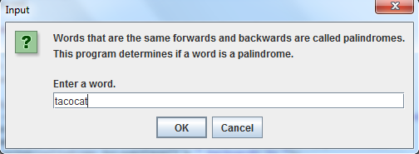

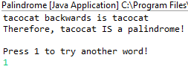

/*

* Justin Mendes

* December 20, 2016

* Unit 4 Activity 1 Program/Question 5

* This program will check the validation of a SIN number with the check digit

*/

**import** java.io.BufferedReader;

**import** java.io.IOException;

**import** java.io.InputStreamReader;

**public** **class** SINChecker

{

**public** **static** **void** main(String[] args) **throws** IOException

{

//Variable Declarations and Initializations

String SIN;

**int** checkDigit, step1, evenDigit = 0, oddDigit = 0, sum = 0;

BufferedReader input = **new** BufferedReader(**new** InputStreamReader (System.***in***));

System.***out***.println("Social Insurance Number\n======================");

System.***out***.println("Enter a Social Insurance Number (no spaces): ");

SIN = input.readLine();

//Separate the checkDigit and the rest of the eight digits

checkDigit = Character.*getNumericValue*(SIN.charAt(8));

SIN = SIN.substring (0,8);

**for** (**int** i = 1; i != SIN.length() + 1; i += 2)

{

//Step 1: Multiply the digits in the even positions of the SIN

step1 = Character.*getNumericValue*(SIN.charAt(i)) * 2;

//Step 2: Separate the digits individually, this can be done by leaving single digits (already multiplied) and separating the multi-digit numbers (multiplied)

**if**(step1 >= 10)

{

step1 = (step1 % 10) + Math.*round*((step1 / 10));

}//end if

evenDigit += step1;

//Step 3: Add together all of the odd position digits that have not been multiplied by 2.

//(which means if the odd number is not the same value as an even number in the SIN then add it to oddDigit)

**if** (Character.*getNumericValue*(SIN.charAt(i)) != Character.*getNumericValue*(SIN.charAt(i - 1)))

{

oddDigit += Character.*getNumericValue*(SIN.charAt(i - 1));

}//end if

sum = evenDigit + oddDigit;

}//end loop

**if** (Math.*round*(((sum / 10) + 0.5)) * 10 - sum == checkDigit)

{

System.***out***.println("The check digit of this SIN is correct.");

}//end if

**else**

{

System.***out***.println("The check digit of this SIN is NOT correct.");

}//end else

}//end main

}//end class

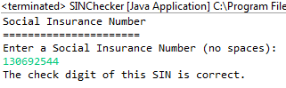

/*

* Justin Mendes

* December 20, 2016

* Unit 4 Activity 1 Program/Question 6

* This program will convert a binary number into its decimal form

*/

**import** java.io.BufferedReader;

**import** java.io.IOException;

**import** java.io.InputStreamReader;

**public** **class** BinaryConverter

{

**public** **static** **void** main(String[] args) **throws** IOException

{

//Variable Declarations and Initializations

String binary;

**int** value = 0, exponent = 0, sum = 0;

BufferedReader input = **new** BufferedReader(**new** InputStreamReader (System.in));

System.out.println("Binary Number Converter\n==================");

System.out.println("Binary numbers only contain the values 0 and 1 (hence BI-nary)");

System.out.println("Enter a binary number to be converted from binary to decimal (8 characters of 0 or 1):");

binary = input.readLine();

**for** (**int** i = binary.length() - 1; i != - 1; i--)

{

value = (**int**) Math.round((Character.getNumericValue(binary.charAt(i)) * Math.pow(2, exponent)));

exponent++;

sum = value + sum;

}//end for

System.out.println("The binary number " + binary + " = " + sum);

}//end main

}//end class

